Design of Pepper Harvesting Device
R. Senthil Kumar¹,Viharika Cherukula², Poorva Saxena³, Avani Bangalore⁴, Sukanya Banerjee⁵
Department of Electrical and Electronics Engineering,
SRM University, Chennai, Tamil Nadu, India.

¹rskrren@gmail.com ²viharika.veena@gmail.com ³poorva.1996@gmail.com

Abstract: Agriculture is the backbone of India and it is the second largest producer of Pepper in the world. Pepper is known as the “King of Spices”. Traditionally, Pepper which is located at a height of 20ft to 30ft, is harvested manually by the aid of a bamboo ladder. Improvisations done to make the ladder more efficient have failed practically and could not solve the farmer’s problems. The driving force behind this work is to eliminate the tedious and risk bearing task of plucking pepper seeds in the clusters of pepper at such heights without any protection. In this regard, a static automated device is designed that would detect the pepper, cut the Pepper and collect it simultaneously. The device would provide a solution to the pepper harvesting method and improvise the production of pepper by reducing the time to harvest them and most importantly, by avoiding the risk bearing tasks that the farmers go through during the harvesting of pepper at such altitudes.

Keywords: Agriculture, Pepper harvesting, static automated device, Image processing, Haar-Cascade, Scissors.

- Introduction:
Pepper is a largely produced and exported spice from India, nearly seventy five percent of the Pepper comes from Kerala, The Malabar Region. [1][2] India is also the largest consumer of this spice. [3]The Pepper plant grows as a bunch and the seeds are initially green in colour and turns into a scarlet red colour when they are ready to be harvested. [4].
The traditional methods of harvesting bear high risks. The method involves climbing a ladder crafted out of bamboo without any support or safety equipment. Innovations have taken place to aid the harvesting procedure. The conventional bamboo ladder is improvised in various ways. One method offers the extension of a rigid ladder that would reach that altitude where the pepper clusters grow, and then the farmer had to pick the seeds manually.[5][6] The improvisation of the ladder does not solve the problem completely as the farmer still has to pick the pepper seeds manually and check if the seeds are ready to be harvested manually.[7] Another innovation is the cutter device where the farmer has to cut using that mechanical apparatus instead of cutting manually.[8] This procedure too involves the climbing of the farmer to such heights This consumes a lot of time and at times the pepper that is harvested late would be spoilt over time.[9][10]
To address all these issues, a static automatic device which can detect pepper and cut the cluster that matches the set definitions is designed.[11] The device consists of a pair of mechanical scissors. [12]The Camera captures the image of the pepper cluster on the tree, if it matches the set parameters, and the pepper cluster is cut and collected in a sac through the attached funnel apparatus. [13] This procedure does not require the farmer to climb any sort of ladder and traverse those heights. He would be at the ground station and has to either hold the device or place it on a tripod stand. Any sort of accidents involved in the traditional methods is completely avoided.[14][15].

- Image processing for Pepper Detection:
Image Processing is basically done to extract the required features or any aspect of an image by converting it into digital signal. The Pepper detection is done by Image Processing. The input images captured by the camera are processed by applying mathematical operations on the image and Pepper is detected by applying the mathematical operations specified by the parameters that are set depending upon the requirement. [16].
The detection of Pepper is done using an object detection algorithm known as Haar-Cascade. Traditionally, object detection was done by studying every pixel of the image in terms of RBG pixels. A Haar-like feature considers neighboring rectangular regions at a specific location in a detection window and then sums up the pixel intensities in each region of the image captured. The difference between the sums of these pixels is calculated mathematically. This difference is then used to categorize subsections of an image for processing. Each subsection is studied in order to exit loop declaring that the entire frame in front the camera eye is studied properly.
Figure 1: Edge Features
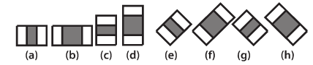
Figure 2: Line Features
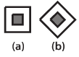
Figure 3: Center Surround Features
The detection of objects using Haar Cascade is usually involved in Face Detection, Finger detection, Hand detection etc. The area near the eyes and the area near the cheeks are different and this difference in the pixels is studied either by using edge features, line features or center surround features depending upon the area of window in which it is studied. The XML files for the corresponding are developed using a number of images taken for study. The same procedure is applied in this case and pepper is detected using either of the feature detection method.

Figure 4: Pepper Detection using Edge Features (a)

The Pepper is detected by moving a window over the image captured by the camera. Each stage of the classifier labels the location of the pepper in the image as either positive or negative. Positive refers to the existence of pepper in the image and negative refers to the absence of pepper in the image. The negative result is followed by the shifting of the window and check the next set of pixels. This process is continued till all the pixels in the image are tested for the existence of pepper in it. A false positive means that the labelling process falsely determines, that the pepper is located in the image captured even if does not exist. A false negative occurs when the classifier is unable to detect the pepper from the image. For accuracy, each stage of the cascade must have a low false negative rate, because if the pepper is classified as no pepper, then the classification of that branch stops, with no way to correct the mistake made. However, each stage can have a relatively high false positive rate, because even if the n-th stage classifies the non-object as actually being the pepper, then this mistake can be fixed in n+1-th and subsequent stages of the classifier.
The process is carried out by building an XML (Extensible Markup Language). XML files are data carrying files. They contain all the pepper images taken under different locations, positions, angles, lighting conditions, and weather conditions, nature of their growth and different stages of their growth. An XML file is built using a number of pepper images for whom the area of interest is specified for each image. When an image is taken by the camera, it starts processing the image and starts looking for common features among the images given and the image taken. It applies Haar feature extraction and decides whether the image taken has pepper or not.

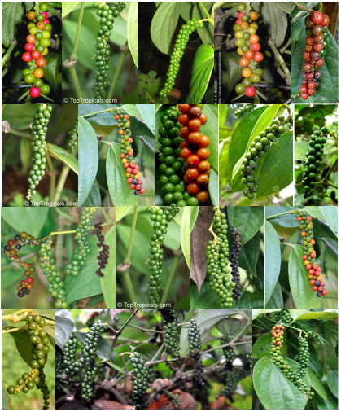
Figure 5: Pepper images for XML file.

- Cutting Mechanism:
The Pepper that is ready for harvesting is cut immediately after the detection of the pepper takes place through Haar Cascade method. The scissor movement is then actuated by a DC motor that had a torque of 5 kg-cm and a speed of 60rpm which cuts the pepper in 1msec after it aligns itself horizontally. The horizontal position to cut the pepper is very important and this is achieved by the rack and pinion mechanism provided. A trail is provided below such that it would slide along the trail to adjust its horizontal position according to the feedback given by the camera after processing the image taken. To cut the pepper cluster via a scissor both arm of the scissor should be controlled. Instead, in this device we have kept one arm of the scissor constant and other arm is controlled by the DC motor. This reduces the complications involved in controlling both the arms simultaneously as the speed of operation should be in coordination with each other in order to cut the pepper accurately. It would even require two motors for controlling both the arms which would require more power and further complicates the design of the device. Controlling one arm would provide the same strength in the cutting and the design would remain simple, which is very essential. The position of the scissor too, is very important. It is placed exactly below the camera such that the image captured by the camera would contain the pepper and scissor would cut the neck of the pepper cluster correctly. The scissor is placed 1 cm below the camera’s eye.

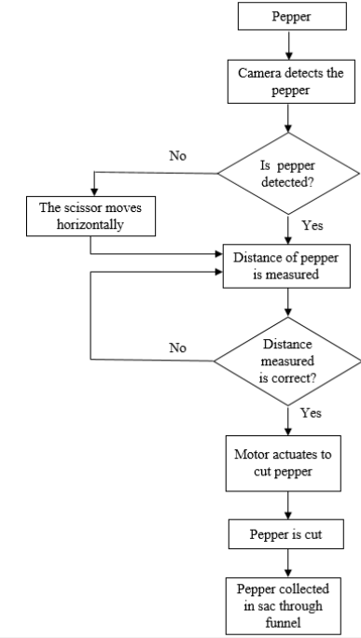
Figure 6: Pepper Harvesting Algorithm
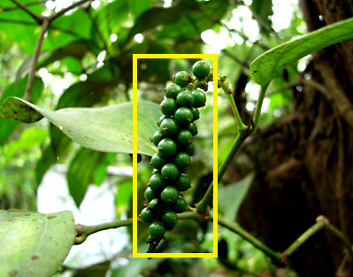
Figure 7: Pepper detected
- Hardware Mechanism:
The Mainframe is built using Acrylic as it is a light weight plastic that has a high tensile strength. This reduces the risk of damaging the device if it would fall from that height. It provides the necessary strength to hold all the Electronics and being an insulator would not cause any sort of conduction. The Mainframe is mounted over the telescopic stick. The telescopic stick is chosen such that it would be extended to a maximum of 40 ft high from ground level. This would make sure it would be appropriate the tallest pepper trees aswell. The heart of the device is the processor. We have Raspberry Pi 3 which has 3 GB RAM and a 1.2GHz processor. The Mainframe is divided into two structures. The lower structure contains the Raspberry Pi 3 , a DC motor driver board (L293d), a DC motor along with the rack and pinion, and a 9V battery to power the DC motors. The upper structure consists of the scissor at the lower side and the motor on the upper side. This section is supported by four rods that follow a trail path and the pinion which is responsible for its horizontal movement. This structure moves horizontally whenever it is required and since it contains the scissor, the position is decided. The lower structure is mounted of the telescopic stick at an angle such that the scissor can cut the pepper cluster exactly according to the image taken by the camera after processing. The funnel is made out of plastic. The funnel and the pipe are polished properly such that it would not affect the Pepper falling through them and the pepper would remain fresh after falling in the sac.

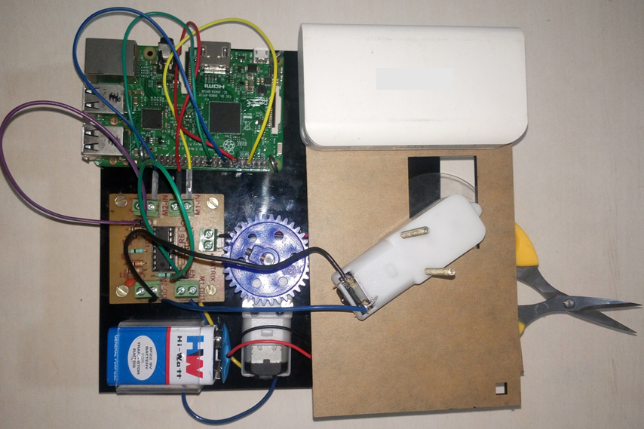
Figure 8: Mainframe

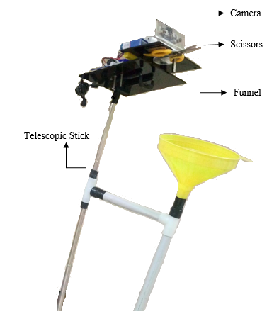

Figure 9: The Device

- Conclusion:
The data obtained from the research done in Kerala farms during the month of December’15 gave us the following results.

The device is designed as such that the farmer does not require any sort of technical knowledge to operate it as there is only on control in his hand. On an average, the device is able to cut a cluster of pepper in 0.3min whereas the conventional methods would take up to 0.8min including detecting and positioning ourselves to cut the cluster of pepper. This reduces the harvest time to a considerable extent as per the survey conducted in the Pepper farms along the Malabar Coast of kerala state. The device also reduces the number of accidents that take place in this field drastically. The makes the device very useful for the farmers. The production of pepper would rise as the pepper that is spoilt due to late harvesting would not occur and time loss sue to accidents is reduced. Most importantly, the farmer does not lose his job as he as to be present for supervision. Only the effort taken by the farmer is reduced by using this device.

REFERENCES:

[1] Rahul M¹ , Prakash V. Unakal² , Gopinath C.³, Sastech journal, Volume 11, Issue 2, Sep 2012 on Design and Development of a Pepper Plucking Equipment to Facilitate Pepper Harvesting

[2] Paul A.Funk¹ and Dale E.Marshall², CAB International 2012 on Pepper Harvest Technology

[3] K S K Aneeshya¹, G K Krishnanunni¹ & V Ganesan² , Journal of Spices and Aromatic Crops Vol. 22-2013 on Development of a black pepper harvester

[4] Shivaji Bachechea¹, Koichi Oka² and Hideto Sakamoto³, JSME Conference on Robotics and Mechatronics-2012 Development of Thermal Cutting System for Sweet Pepper Harvesting Robot in Greenhouse Horticulture

[5] Yu-Li You, Wenyuan Xu, Allen Tannenbaum, And Mostafa Kaveh, Fellow, IEEE, IEEE TRANSACTIONS On Image Processing, Vol. 5, No. 11, November 1996 on Behavioral Analvsis Of Anisotrodic Diffusion In Image Processing

[6] Jong-Sen Lee, IEEE Transactions On Pattern Analysis And Machine Intelligence, Vol. Pami-2, No. 2, March 1980 on Digital Image Enhancement and Noise Filtering by Use of Local Statistics

[7] Mustafa E. Yildirim, J. S. Park, J. Song, and B. W. Yoon International Journal of Computer and Communication Engineering, Vol. 3, No. 2, March 2014 on Gender Classification Based on Binary Haar Cascade

[8] R. Padilla, C. F. F. Costa Filho and M. G. F. Costa, World Academy of Science, Engineering and Technology International Journal of Computer, Electrical, Automation, Control and Information Engineering Vol:6, No:4, 2012 on Evaluation of Haar Cascade Classifiers Designed for Face Detection

[9] Paul Viola Michael Jones, Accepted Conference on Computer Vision and Pattern Recognition 2001 on Rapid Object Detection using a Boosted Cascade of Simple Features

[10] Sander Soo, Institute of Computer Science, University of Tartu on Object detection using Haar-cascade Classifier

[11] Lubomir Bourdev, Jonathan Brandt, Office of Technology, Adobe Systems Inc., 345 Park Avenue, San Jose, CA 95110 on Robust Object Detection Via Soft Cascade

[12] Rainer Lienhart and Jochen Maydt, 2002 IEEE ICIP on An Extended Set of Haar-like Features for Rapid Object Detection

[13] Qing Chen, Nicolas D. Georganas, Emil M. Petriu, Instrumentation and Measurement Technology Conference - IMTC 2007 Warsaw, Poland, May 1-3, 2007 on Real-time Vision-based Hand Gesture Recognition Using Haar-like Features

[14] Qiang Zhu, Shai Avidan, Mei-Chen Yeh, and Kwang-Ting Cheng, Proceedings of the 2006 IEEE Computer Society Conference on Computer Vision and Pattern Recognition (CVPR’06) on Fast Human Detection Using a Cascade of Histograms of Oriented Gradients

[15] Rong Xiao† , Huaiyi Zhu , He Sun and Xiaoou Tang , IEEE 2007 on Dynamic Cascades for Face Detection

[16] Rong Xiao, Ming-Jing Li, and Hong-Jiang Zhang, IEEE Transactions On Circuits And Systems For Video Technology, Vol. 14, No. 1, January 2004 on Robust Multipose Face Detection in Images

